Super Shop Management System

*Md. Shanewaz Akib*

*ID: 2016-3-60-050*

*Course Code: CSE435; Course title: Software Quality Assurance*

*Section: 01; Summer 2020*

*Dept. of Computer Science & Engineering; East West University, Bangladesh.*

**Introduction**

This is a Super Shop Management System which is a web application. Here, there has mainly three interfaces such as admin, employee, and user interface. In the admin and user interface has multiple functionality also. Admin can be add, delete, and update the products in this system. The employee could take payment from customers by using this system. Customers could be purchase products online by using this system.

This system is implemented by the MVC pattern. The frontend of this system which is the user interface are implemented by HTML, CSS, and JavaScript programming. And the backend of this system is implemented by Django (python framework) which are controls data in MySQL and the user interface of HTML, CSS, and JavaScript files.

**Analysis of Sequence Diagram**

1. **Online order procedure by customers (login as a customer)**

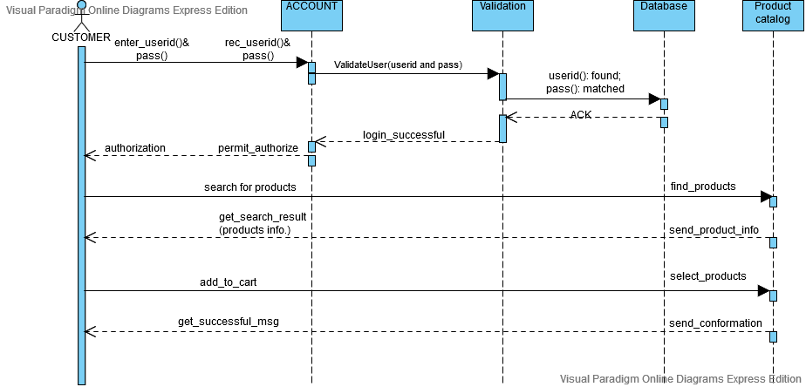

*Figure 1: Online order system by customers*

1. *Finite State Processes (FSP) Code*

CUSTOMER = (enter_userid_pass -> authorization -> search_products -> get_search_result -> add_to_cart -> get_successful_msg -> CUSTOMER).

ACCOUNT = (rec_userid_pass -> validate_user -> login_successful-> permit_authorize -> ACCOUNT).

VALIDATION = (validate_user -> userid_pass_is_found -> ack -> login_successful -> VALIDATION).

DATABASE = (userid_pass_is_found -> ack -> DATABASE).

PRODUCT_CATALOG = (find_products -> send_product_info -> select_products -> send_conformation -> PRODUCT_CATALOG).

||ONLINE_PURCHASE = (CUSTOMER || ACCOUNT || VALIDATION || DATABASE || PRODUCT_CATALOG)

/{enter_userid_pass/rec_userid_pass, authorization/permit_authorize, search_products/find_products, get_search_result/send_product_info, add_to_cart/select_products, get_successful_meg/send_conformation}.

1. *Analysis Diagram*

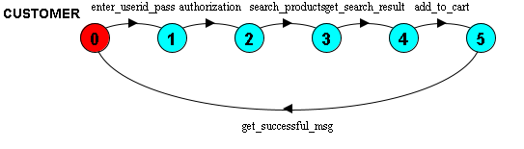

*Figure 1.1: Process of CUSTOMER*

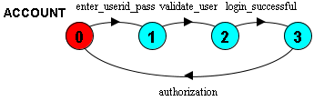

*Figure 1.2: Process of ACCOUNT*

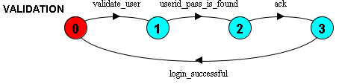

*Figure 1.3: Process of VALIDATION*

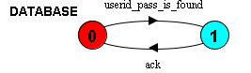

*Figure 1.4: Process of DATABASE*

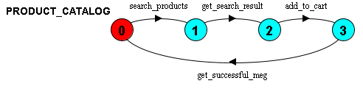

*Figure 1.5: Process of PRODUCT_CATALOG*

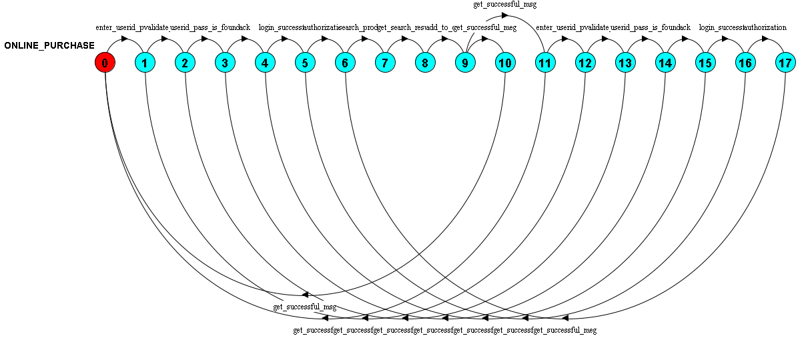

*Figure 1.6: Online Purchase System*

1. **Online Payment procedure**

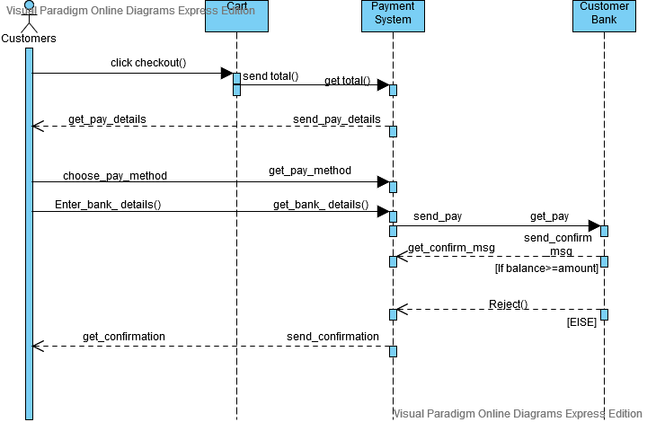

*Figure 2: Online payment system*

1. *Finite State Processes (FSP) Code*

CUSTOMER = (checkout -> get_pay_details -> choose_pay_method -> enter_bank_details -> get_confirmation -> CUSTOMER

|not_success -> CUSTOMER).

CART = (checkout -> send_total_amt -> CART).

PAYMENT_SYSTEM = (get_total_amt -> send_pay_details -> get_pay_method -> get_bank_details -> send_pay -> get_confirm_msg -> send_confirmation -> PAYMENT_SYSTEM

| reject -> not_success -> PAYMENT_SYSTEM).

CUSTOMER_BANK = (get_pay -> send_confirm_msg -> CUSTOMER_BANK

| reject -> CUSTOMER_BANK).

||ONLINE_PAYMENT = (CUSTOMER || CART || PAYMENT_SYSTEM || CUSTOMER_BANK)

/{get_pay_details / send_pay_details, send_total_amt / get_total_amt, choose_pay_method / get_pay_method, enter_bank_details / get_bank_details, send_pay / get_pay, get_confirm_msg / send_confirm_msg, get_confirmarion / send_confirmation }.

1. *Analysis Diagram*



*Figure 2.1: Process of Payment System*



*Figure 2.2: Process of Customer Bank*

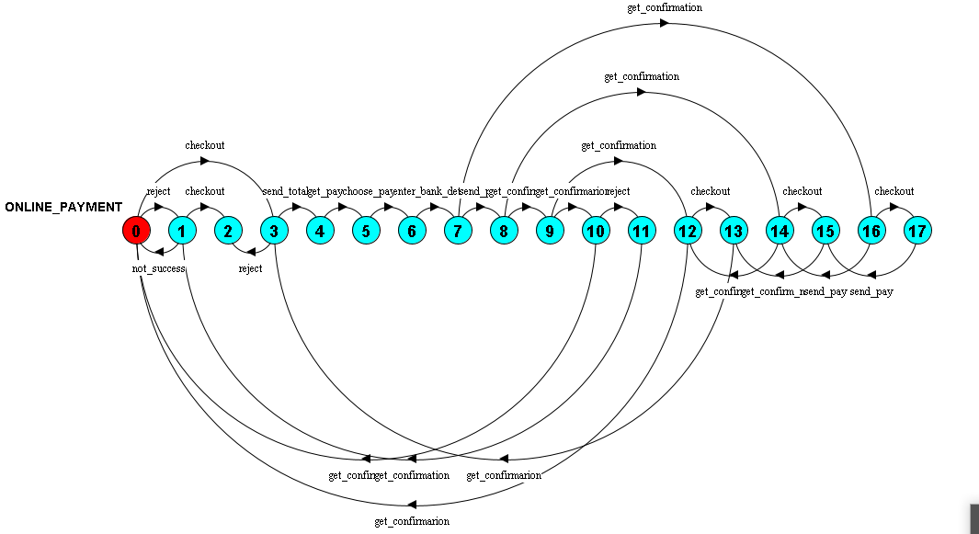

*Figure 2.1: Online Payment System*

*Figure 2.3: Online Payment System*

1. **Insert/Delete/Update products by Admin (login as admin)**

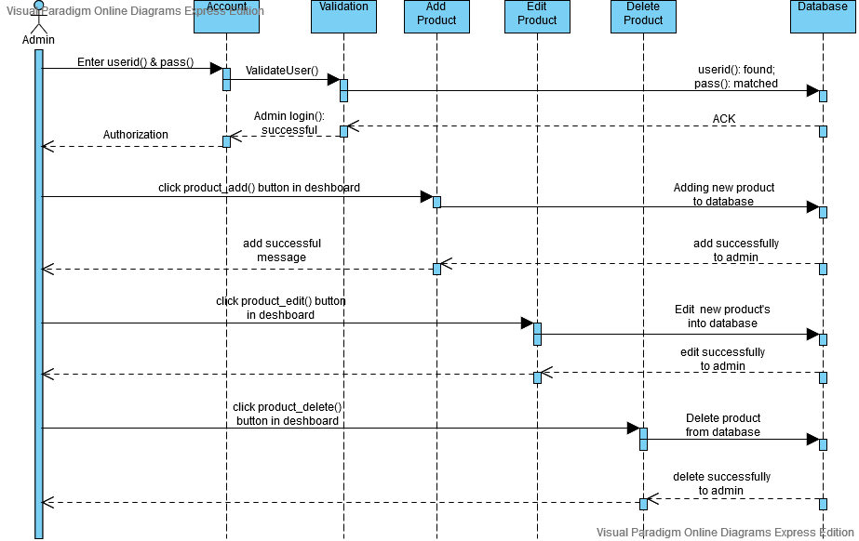

*Figure 3: Admin Panel System*